|  |
| --- |
| **FlyAway**  **(Application Screenshots)** |

**Version History:**

|  |  |
| --- | --- |
| Author | Hajaeba Kemal |
| Purpose | Screenshots of the application |
| Date | 10th September 2022 |
| Version | 1.0 |

Table of Contents

1. Landing Page 3

2. Login Page 4

3. SignUp Page 5

4. Flight List Page 6

5. Confirmation Page 7

6. Ticket Detail Page 8

# Landing Page

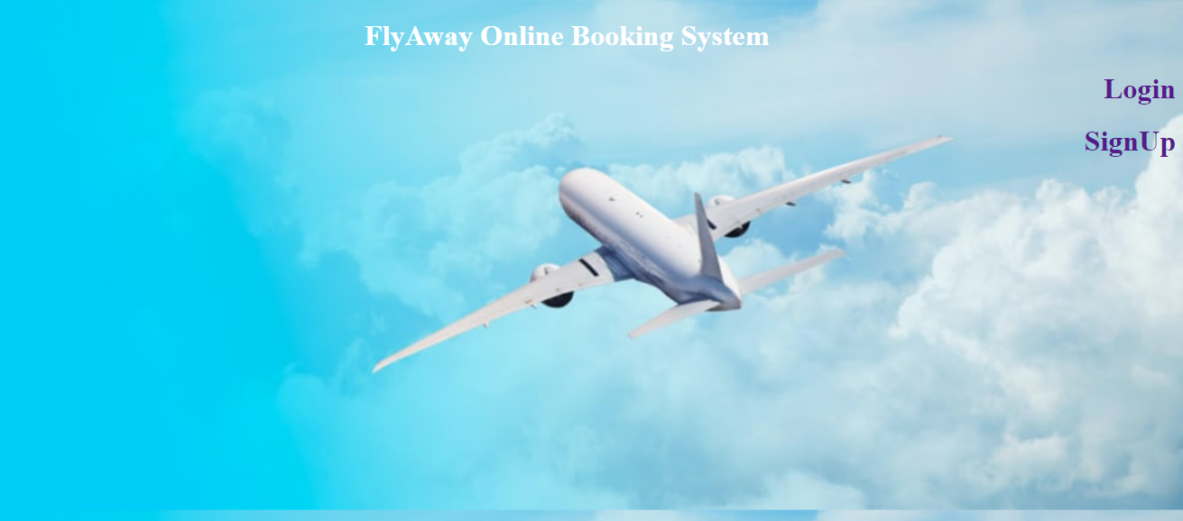

# Login Page

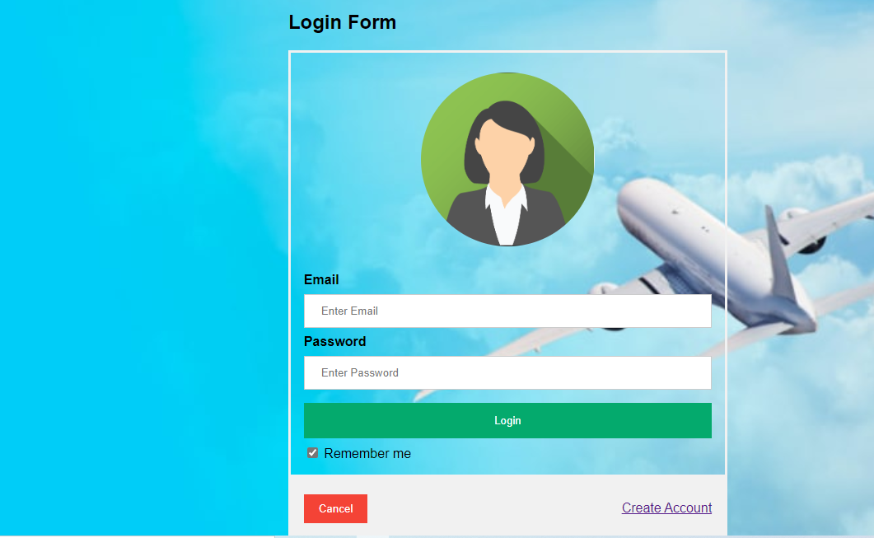

# SignUp Page

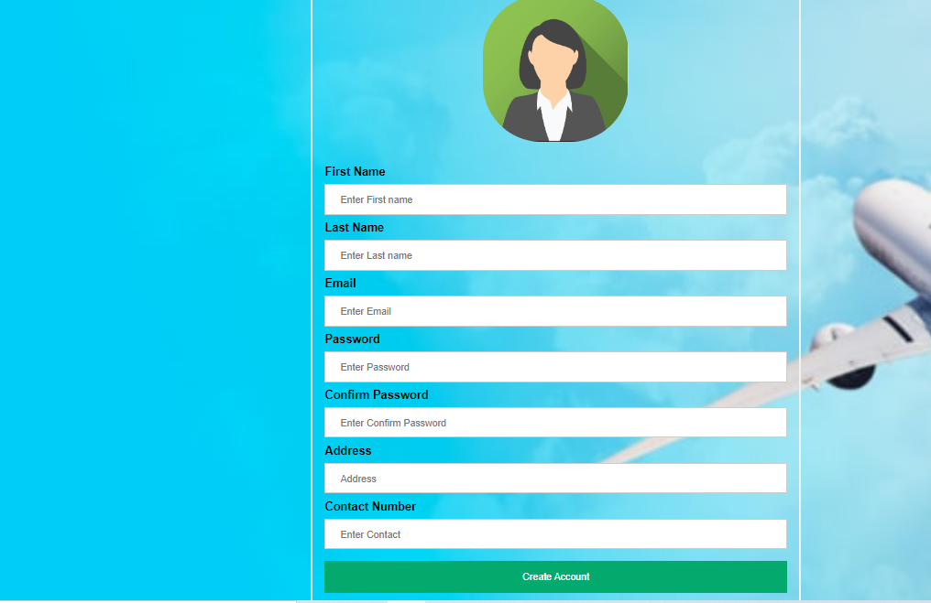

# Flight List Page

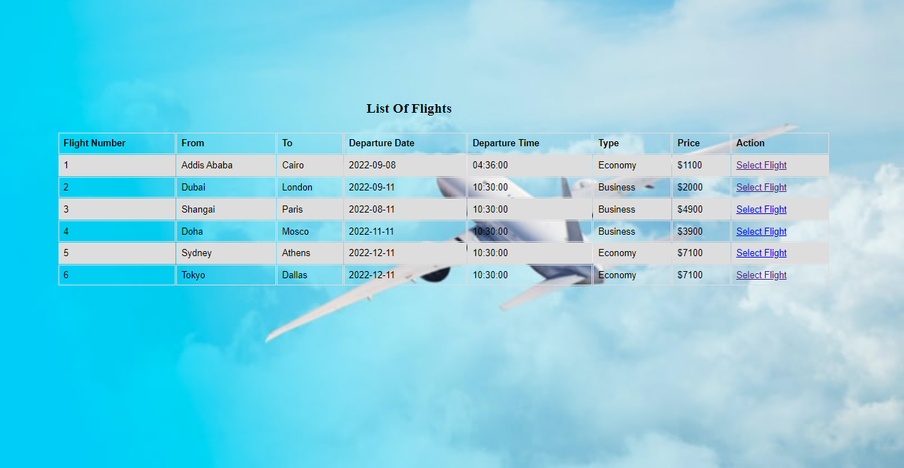

# Confirmation Page

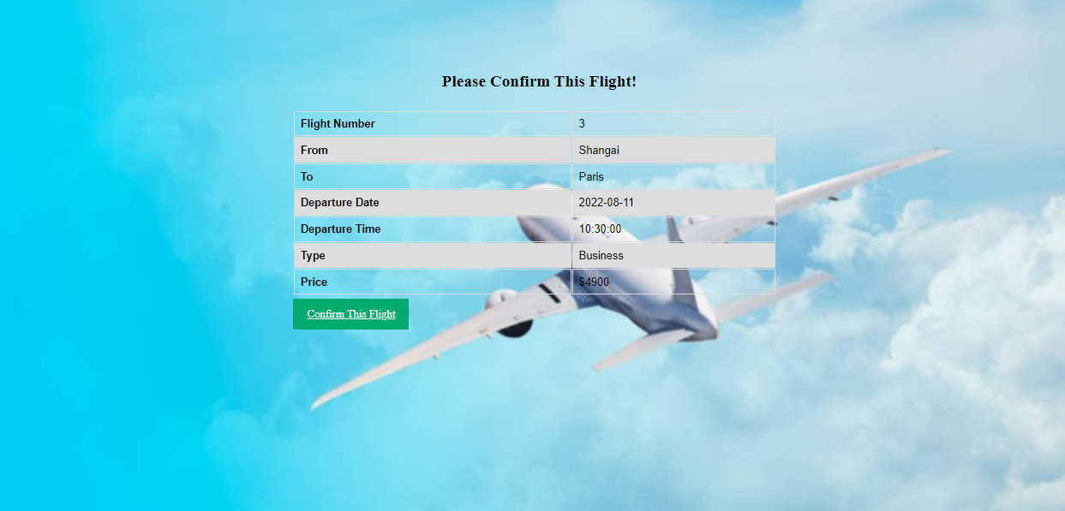

# Ticket Detail Page

